How to set up a Short WebEx Meeting Link

Schedule a WebEx Meeting as follows

- Go to http://www.ge.com/emeetings
- Select Schedule a Meeting

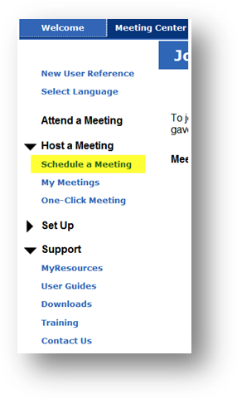

- On the Meeting Information provide details on MTG Topic, password and set it up for next day , for 12 hours

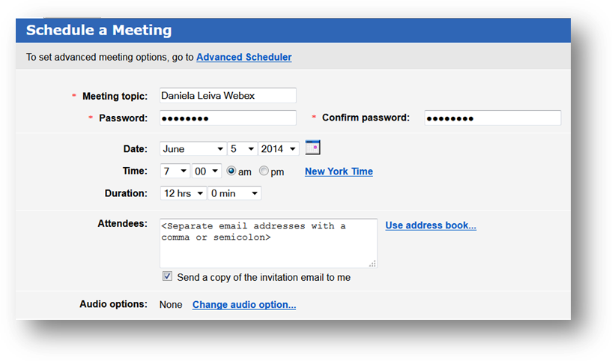

- Select Advance Schedule

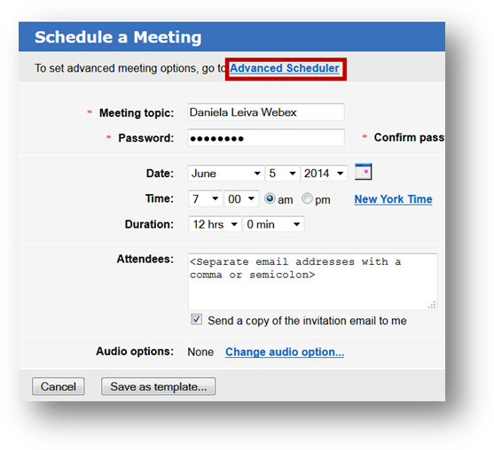

- Select from the left side Menu – Date and Time

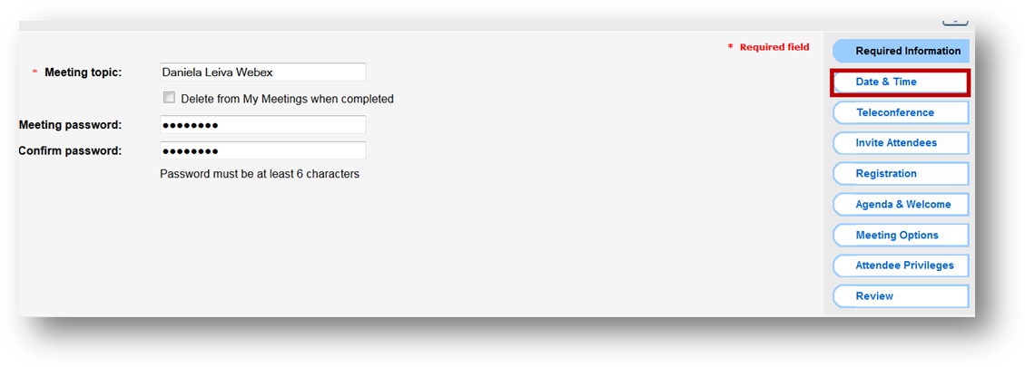

- Select on Recurrence Daily, and Ending No end Date, and save Meeting

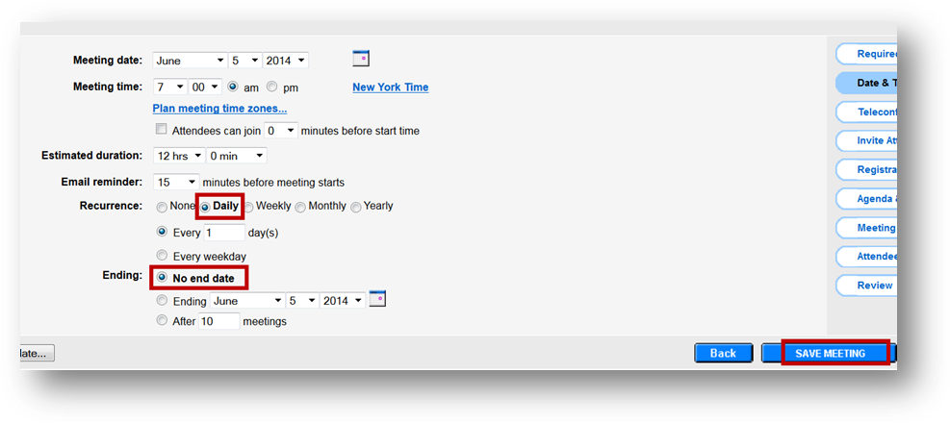

- Select Add to calendar, and open the MTG Calendar

Copy the WebEx Meeting link from body as shown and continue to Steps ( Create Short link)

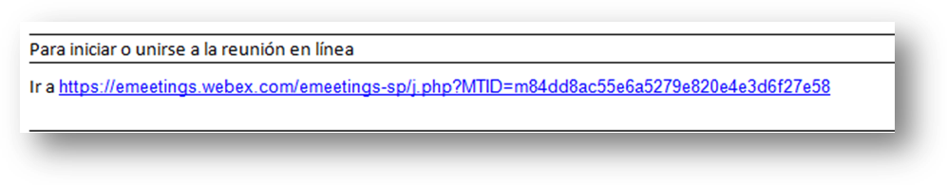

CREATE A SHORT LINK

- Go to http://supportcentral.ge.com

- Click on Personal Items, and select Short Links

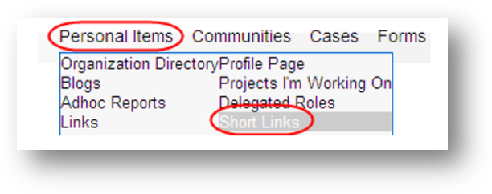

- Copy and paste the meeting URL from step 1 into the Long URL field, type in a name for the short link, and click on Create.

